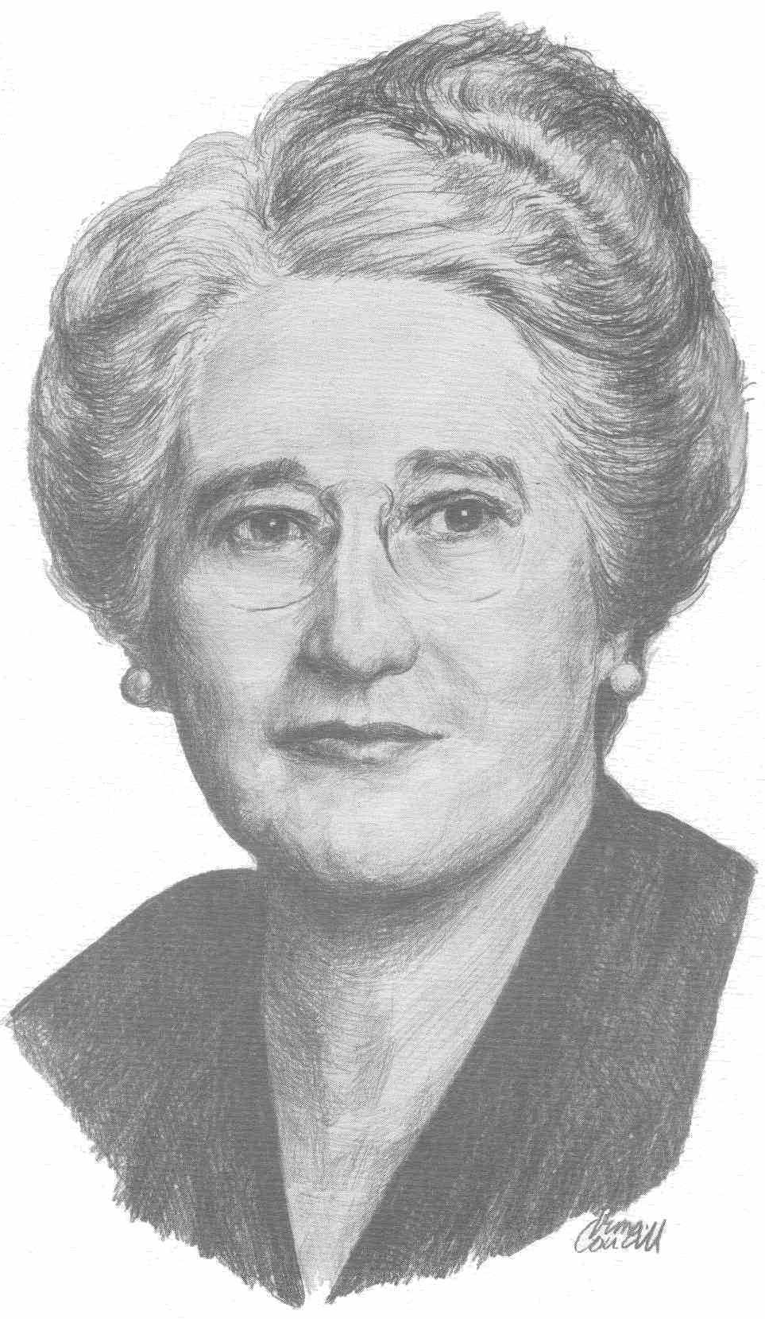

Overview:
Agnes Campbell Macphail was once described as “the most important woman in public life that Canada has produced in the 20th Century”.
In 1921 she blazed a path for women with her election to the House of Commons in Ottawa where she served for 19 years until 1940. In 1943, she became the first woman to sit in the Ontario Legislature, representing the riding of York East (which at the time included East York and a large surrounding rural area).
On March 24, 1993, Mayor Michael Prue proclaimed the first annual Agnes Macphail Day in the Borough of East York in honour of the 50th anniversary of her election to the Ontario Legislature.
In January 1994, East York Council established the Agnes Macphail Award.

Purpose of the Award:
The purpose of the award is to recognize the importance to the East York community of the issues that Agnes Macphail espoused in her long career:
- Women’s rights
- Fairness to seniors
- Criminal justice system and penal reform
- International peace and disarmament
- Access to adequate housing, health care and education

Conditions/Criteria:
An annual award is presented to an East York resident who has made outstanding contributions as a volunteer, advocate, contributor to community life and leader in one or more of the above fields, but is not limited to them. These contributions should be over considerable periods of time.
All living in the former Borough of East York are eligible, with the exception of federal, provincial & municipal elected officials and judges while in office. There are no posthumous appointments.
Nominees from previous years are eligible for re-nomination. Previous recipients are ineligible.
The ideal candidate will live by Agnes’ motto, “Think Globally, Act Locally”.

Nomination Information:
All information requested on the separate nomination form must be submitted and will not be returned. The deadline for receipt is midnight, Thursday, February 7, 2019
Details of:
- Nominator’s testimonial
- Biography/profile of the nominee
- Affiliations
- Letters of support
to be included as outlined on the nomination form.

Note: Only information actually submitted on and with the nomination package will be considered. The Committee is not permitted to contact the nominator for further information.

Agnes Macphail Recognition Committee:
c/o Councillor Paula Fletcher
phone 416 392 4060
Email councillor_fletcher@toronto.ca
100 Queen Street West, Suite C44, Toronto, ON M5H 2N2

2019 Agnes Macphail Award Ceremony:
The Agnes Macphail Award Ceremony will be held on the birthday of Agnes Macphail, Sunday, March 24, 2019, 2 pm, in the True Davidson Council Chambers of the East York Civic Centre, 850 Coxwell Avenue.

The recipient is honoured with a medal, framed certificate of recognition and their portrait on an honour wall in the East York Civic Centre with other recipients..

Donations to the Agnes Macphail Fund:
Each year, the Agnes Macphail Fund receives donations from our citizens to a registered charity of the recipient’s choice, and is presented by the Award recipient at the ceremony.

Please send your contribution to the Agnes Macphail Fund,
c/o The East York Foundation
50 Merritt Road
East York, ON M4B 3K6 A charitable income tax receipt will be issued.

